

**Plastic Writing Instruments**

Pens, mechanical pencils, highlighters, markers, whiteboard markers

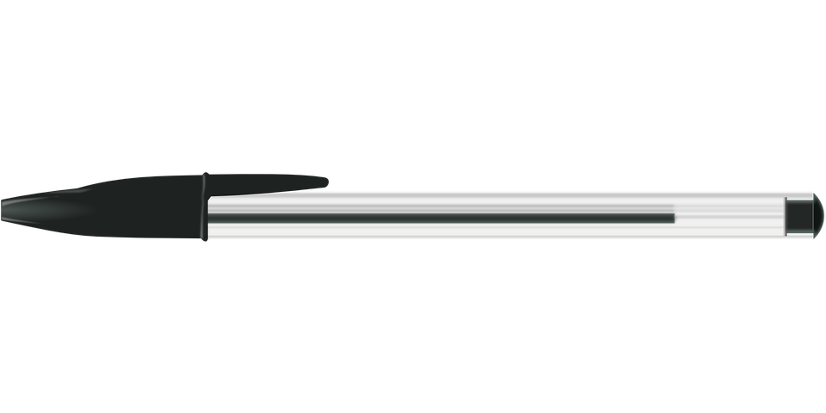

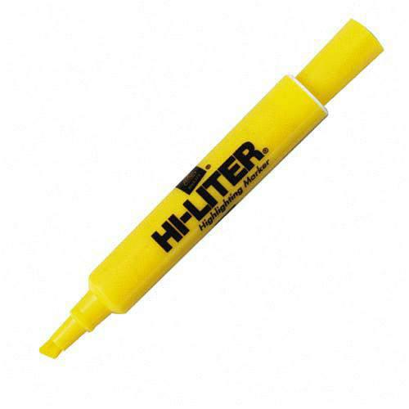

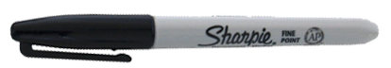

NO pencils, crayons or other office supplies



