Plastic bottles, aluminum cans, juice boxes

**Refundables**

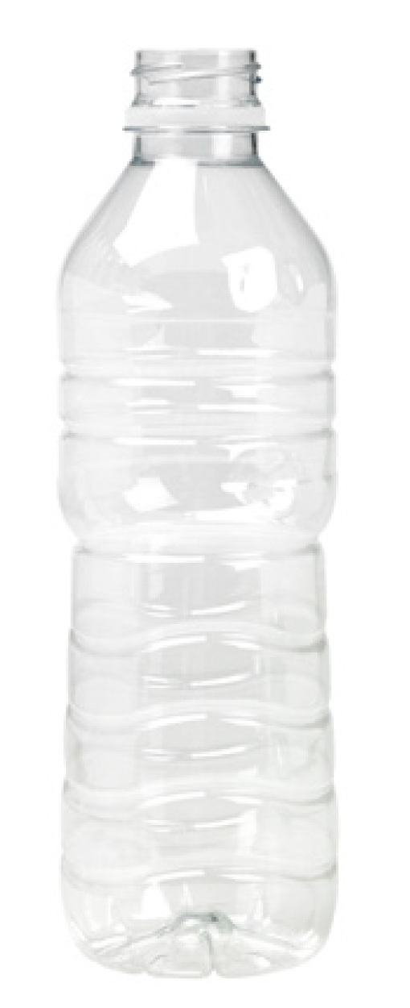

NO liquids, milk cartons, paper cups or food containers

**$**

